<https://www.conduktor.io/kafka/what-is-apache-kafka/>

Conductor :- UI tool for Kafka with so many features.

Topics :- A particular stream of data

* Like a table in a database (without all the constraint)
* Sequence of messages is called a data stream
* We cannot Query topics , use Kafka producer to send data and Kafka consumer to read the data

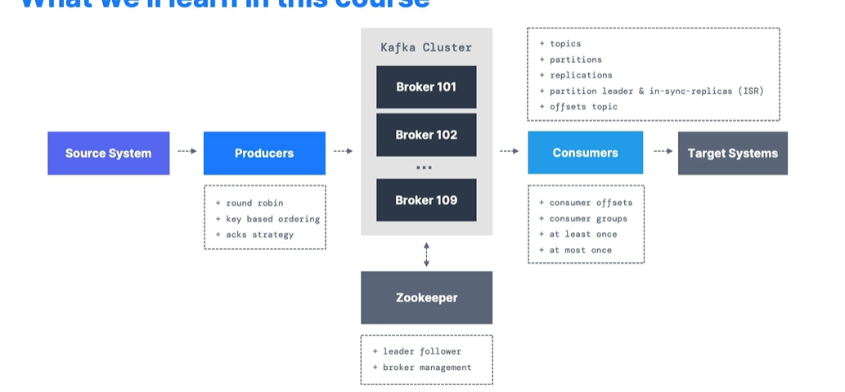

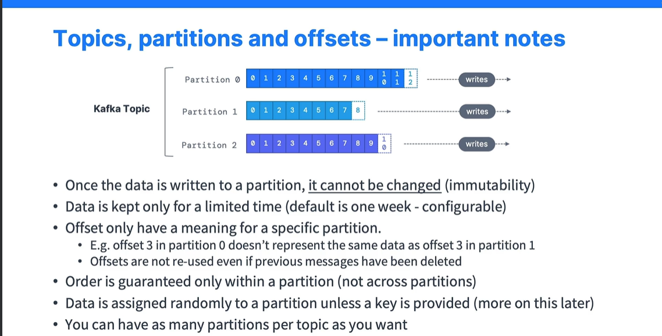

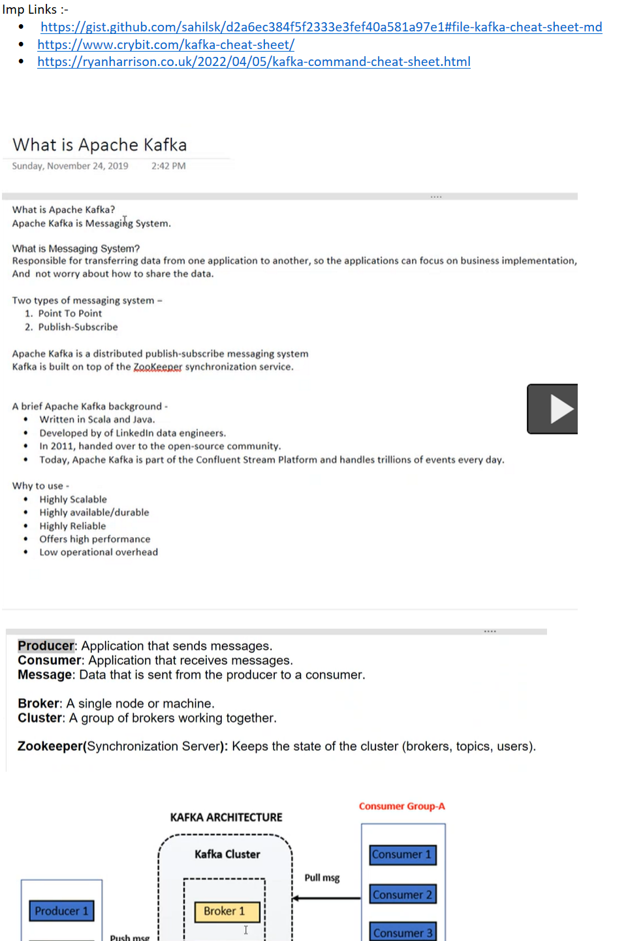  
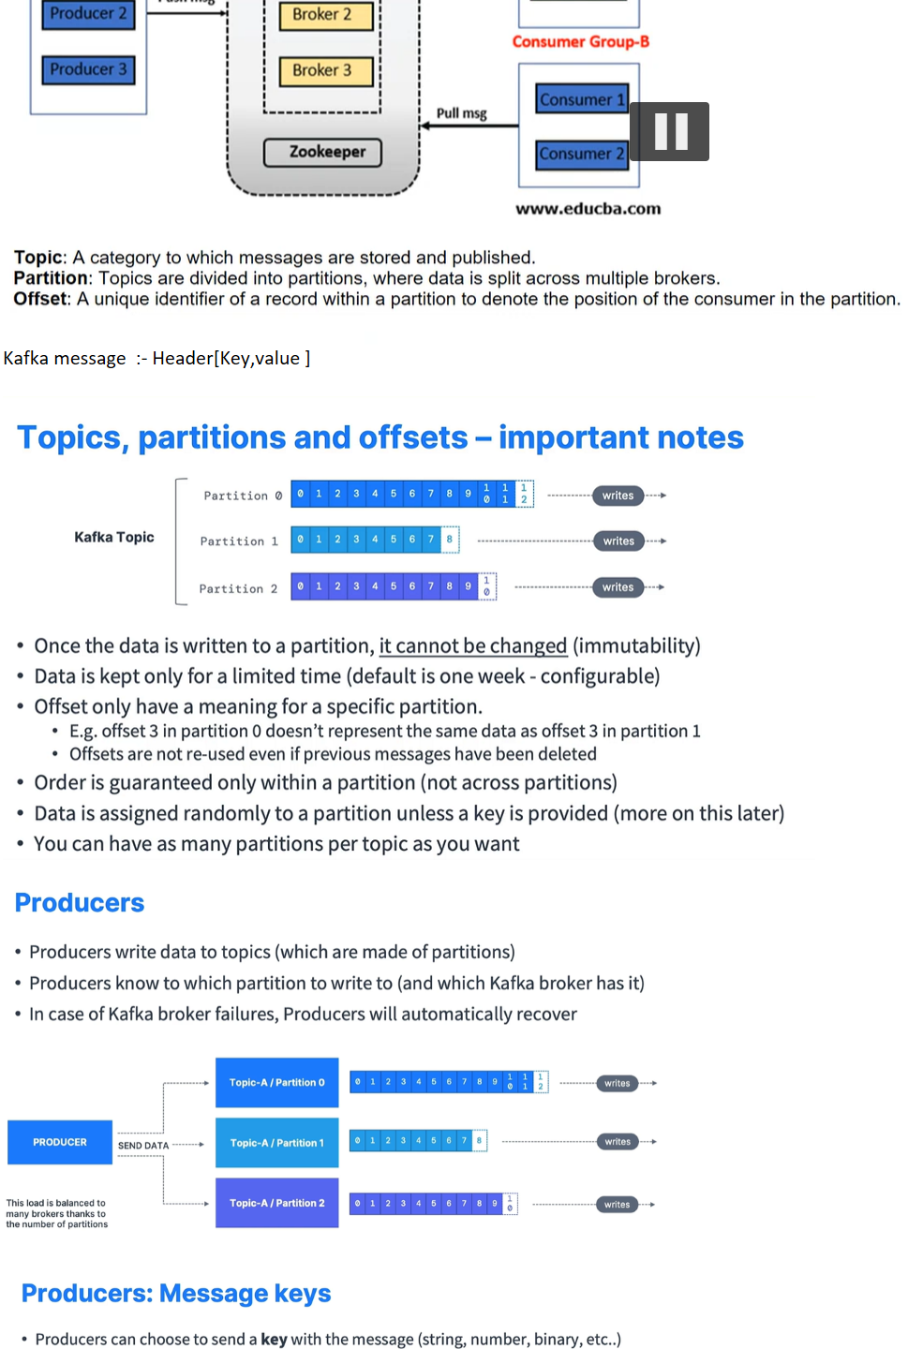  
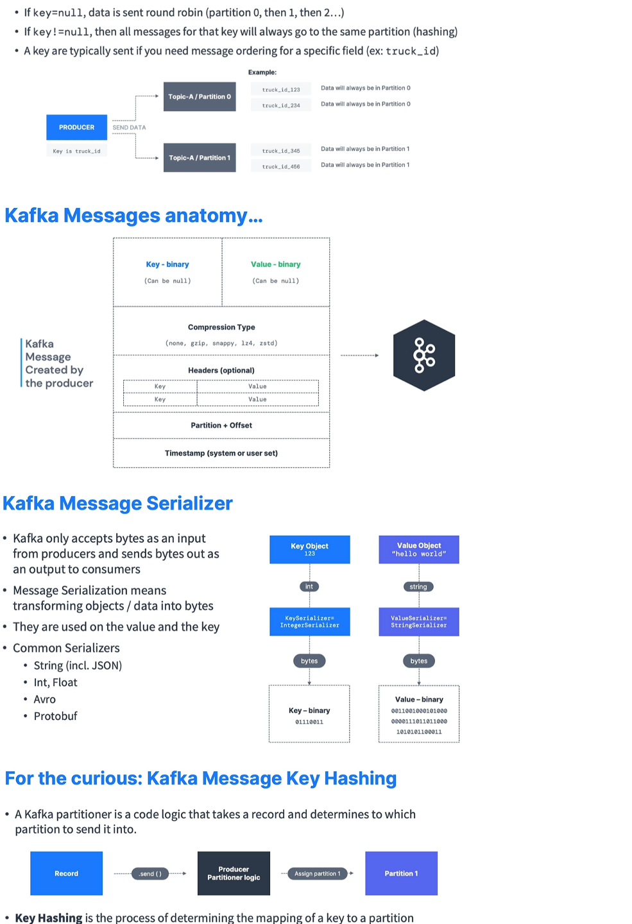  
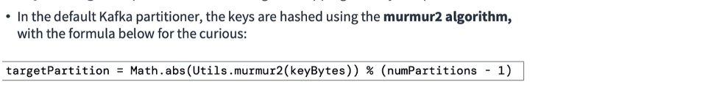

|  |  |  |  |
| --- | --- | --- | --- |
|  |  |  |  |
|  |  |  |  |
|  |  |  |
|  |  |  |

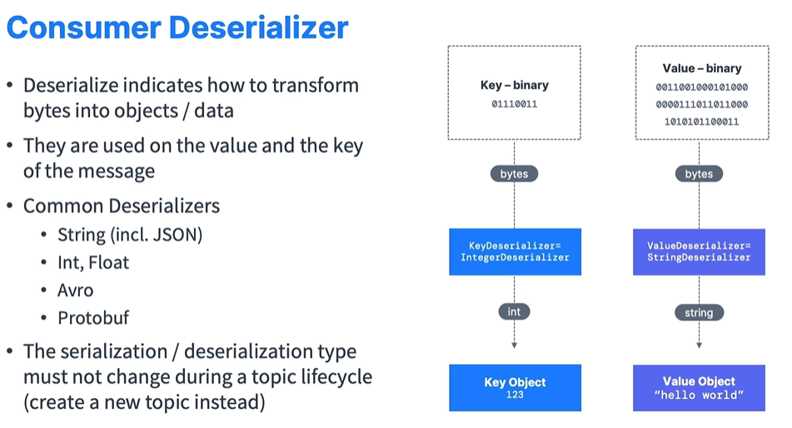

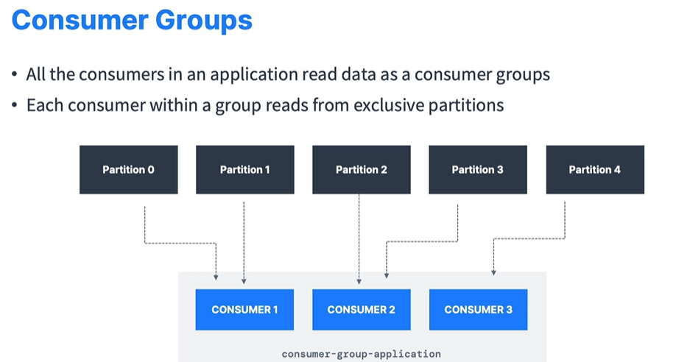

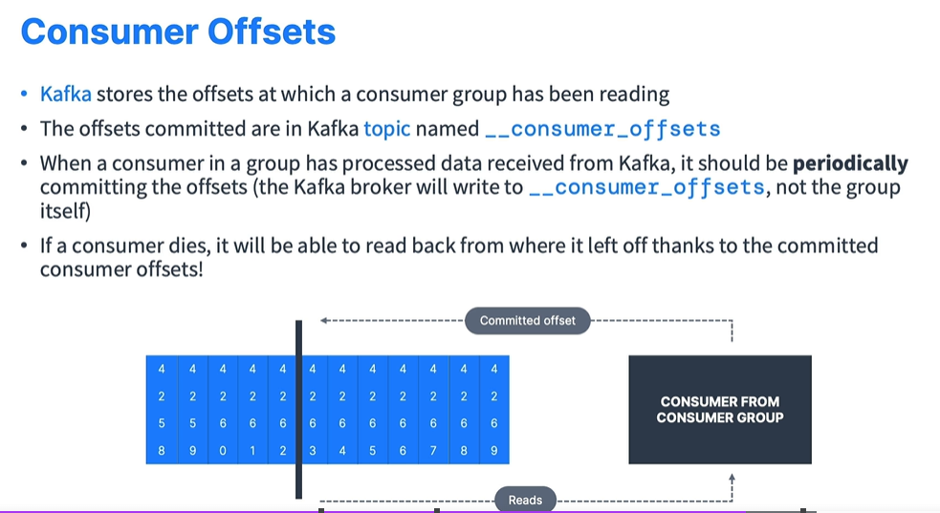

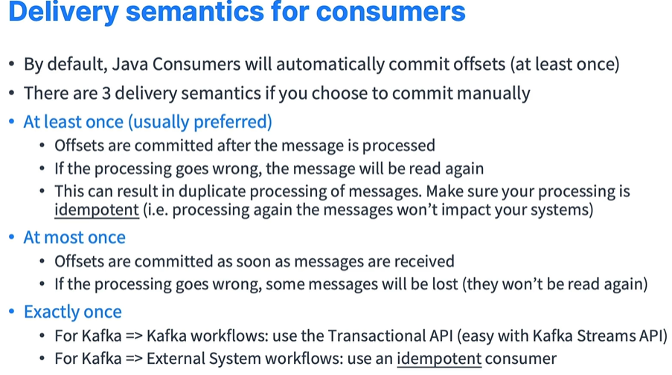

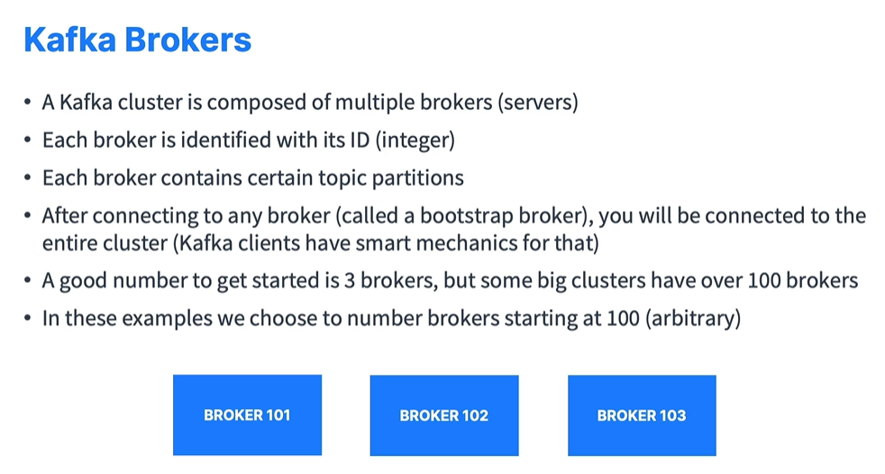

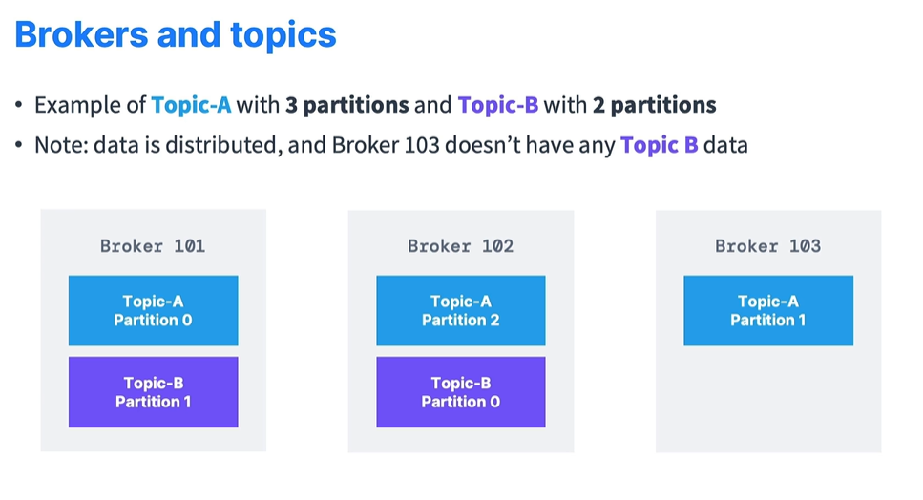

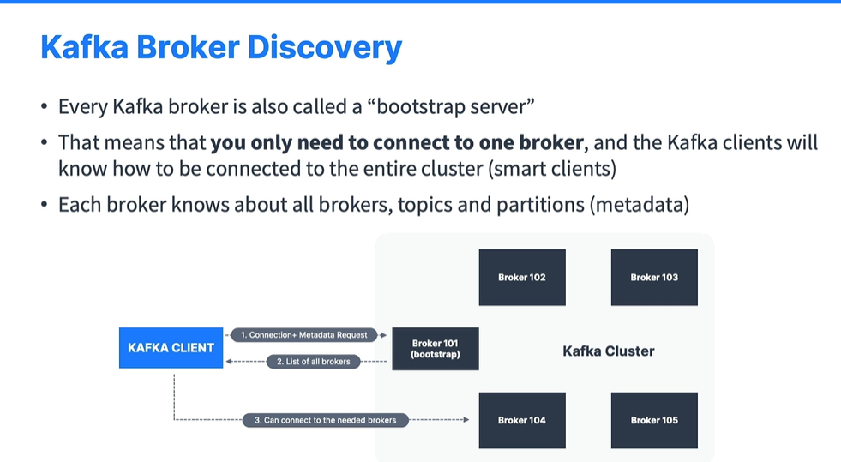

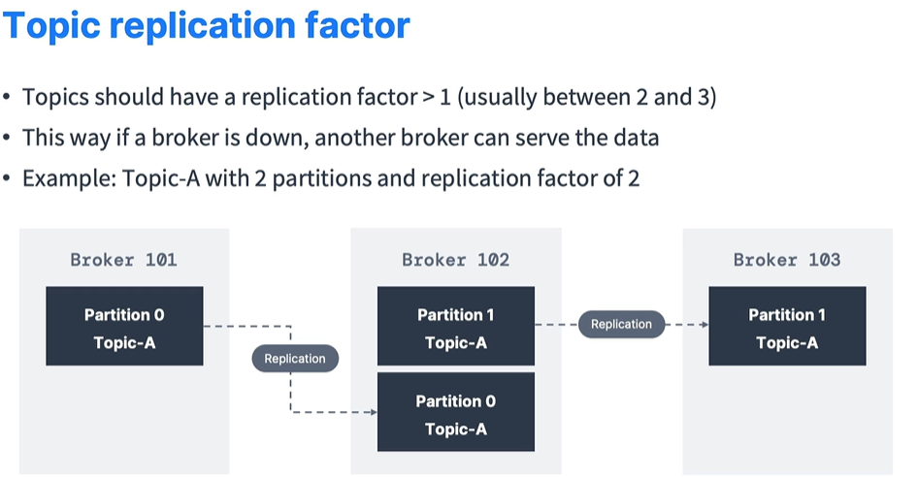

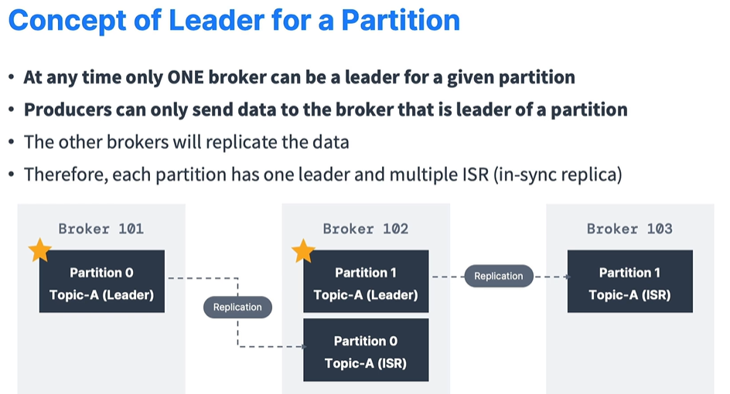

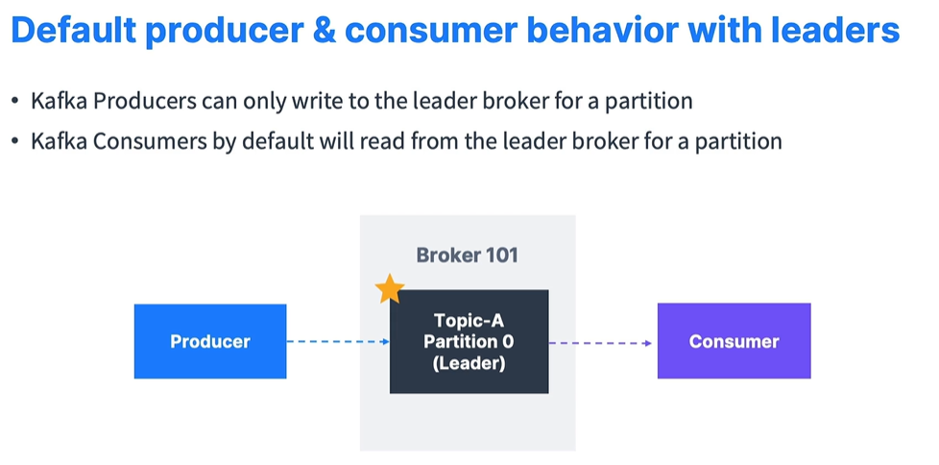

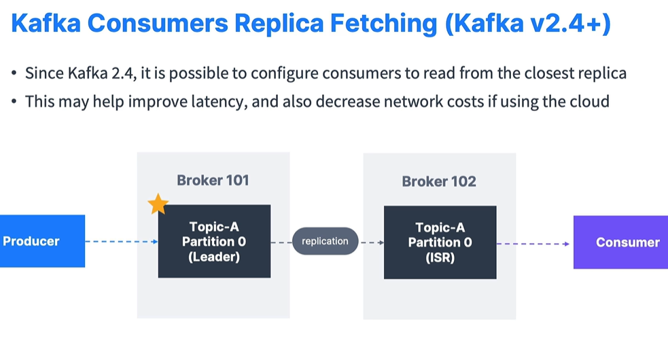

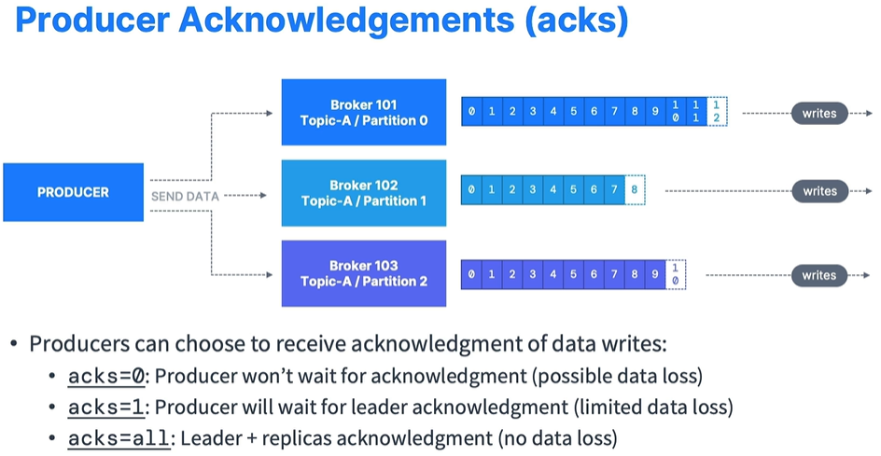

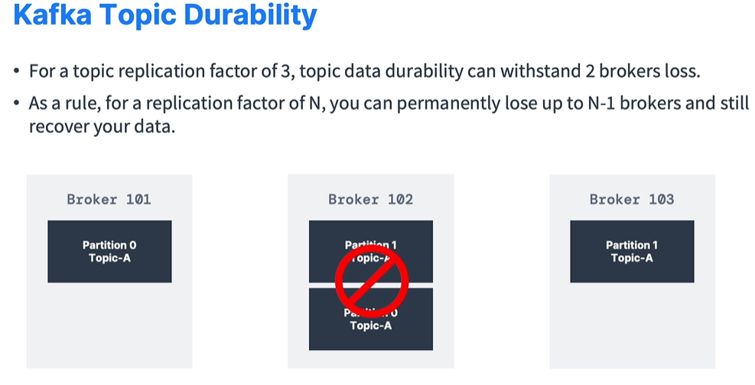

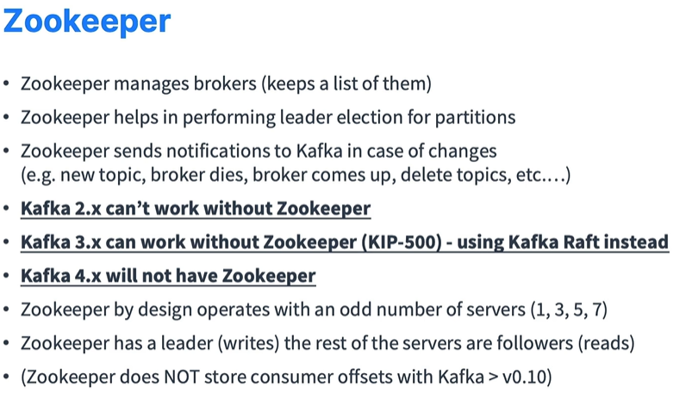

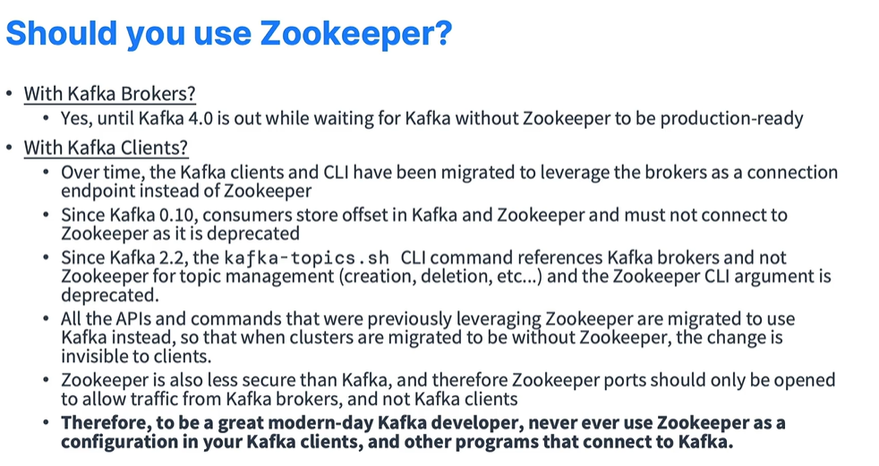

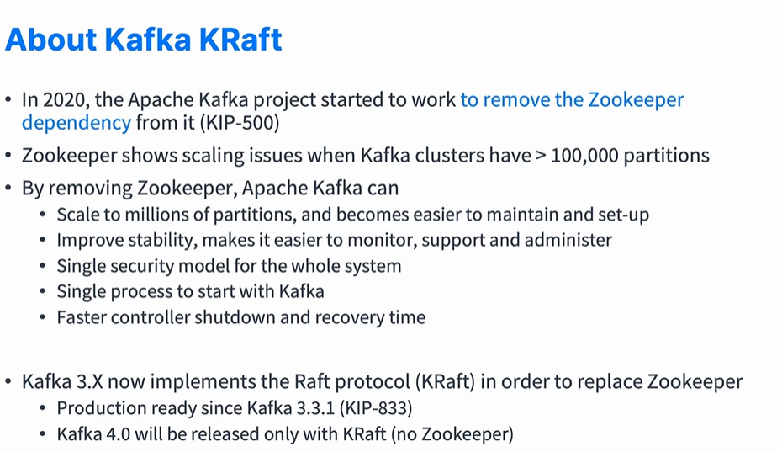

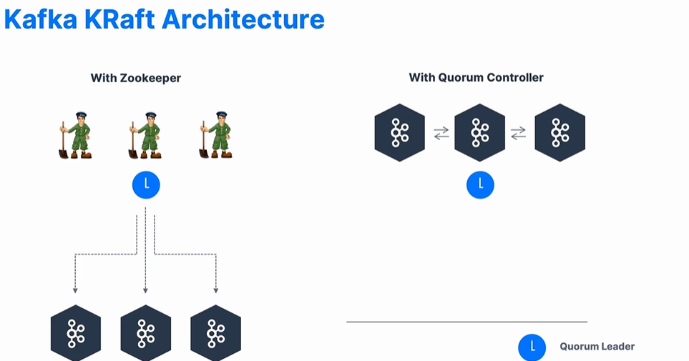

Kafka uses : **ZOOKEEPER** so you need to start it

Kafka maintain messages in **TOPICS**

**LEADER**is the node responsible for all reads and writes for the given partition

Kafka uses key-value pair in **PROPERTY**file format

Kafka is comparable to traditional messaging like **ACTIVEMQ**

Many people use Kafka for **LOG AGGREGATION**

What if consumer dies and comes up after some time : **IT WILL BE READ FROM WHERE IT LEFT USING CONSUMER OFFSET**

Annotation to link producer to channel : **@Output**

Kafka produces a **TOTAL** order over messages in partition

What is guaranteed by Kafka? C**ONSUMER GETS MESSAGES IN SAME ORDER AS THEY ARE PRODUCED**

Kafka is run as a cluster comprised called as **BROKER**

**KAFKA** provides the functionality of a messaging system

The only metadata on a per-consumer basis is called **OFFSET**

Which of the following is true about Kafka : **ALL OF THE ABOVE**

If there are 20 Topics: **40 partitions are required**

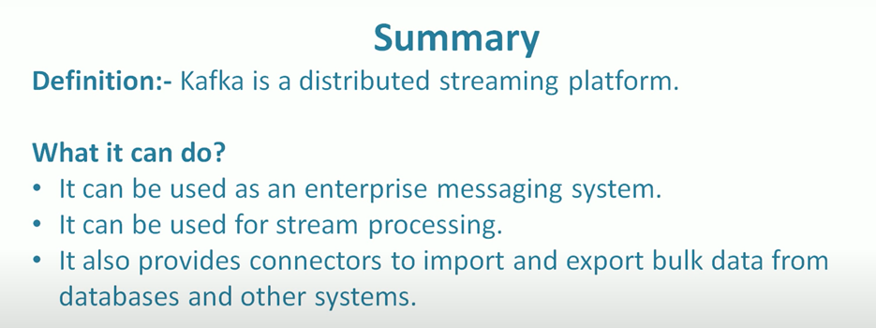

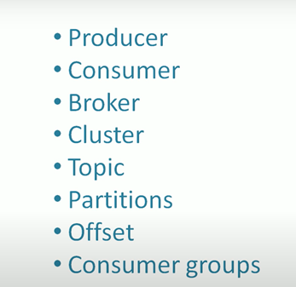

**Producer :- An Application that sends message to kafka**

**Message :- Small to medium size piece of data .**

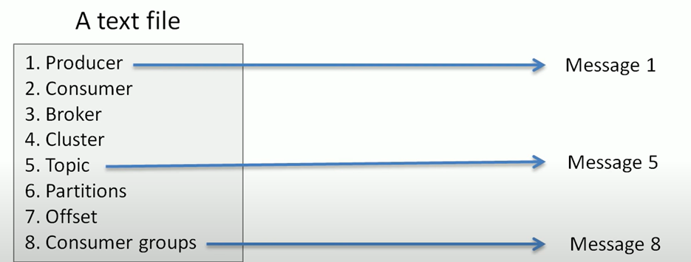

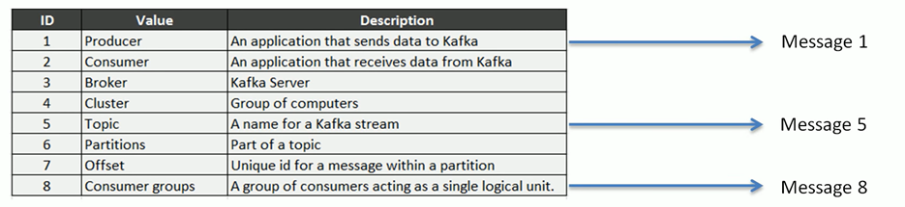

**Consumer :- An application that reads a data from kafka (Kafka Server)**

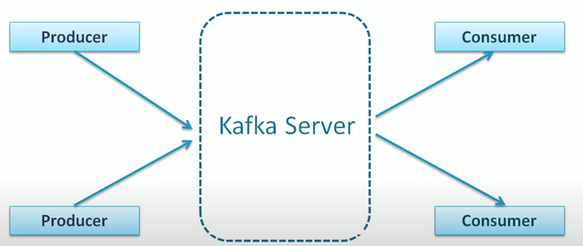

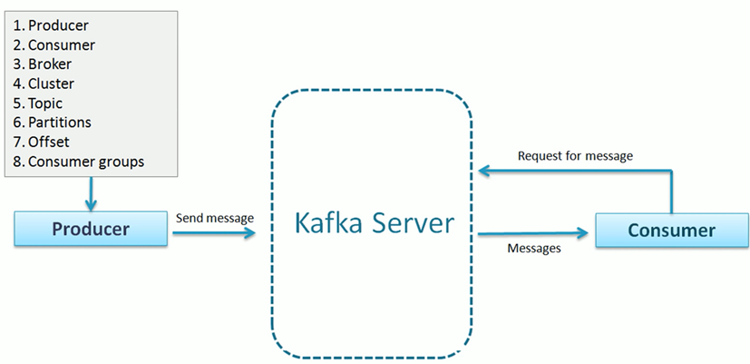

Broker :- Broker are the kafka server(Producer can’t directory send message to consumer)

Cluster :- A group of computers Sharing workload for common purpose

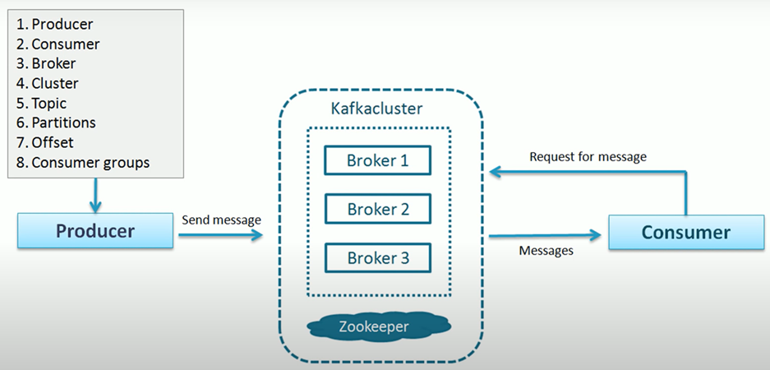

Topic :- A topic is a unique name for kafka stream(Unique name for dataset)

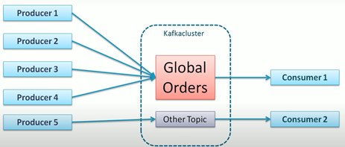

Here Global orders is a topic name

Partitions :- Topic were divided into partition. We have to take decision how many partition we have to made. Every partition sits on a single machine

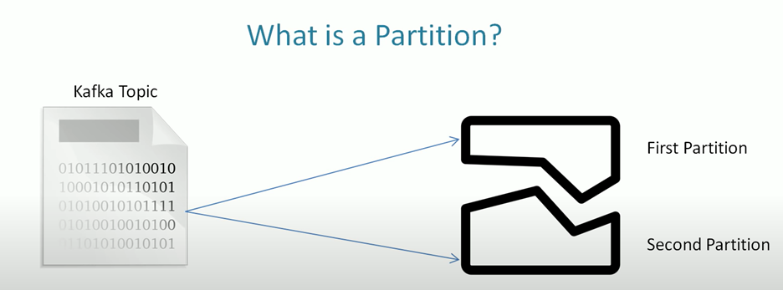

Offset :- A sequence id given to message as they arrive in a partition

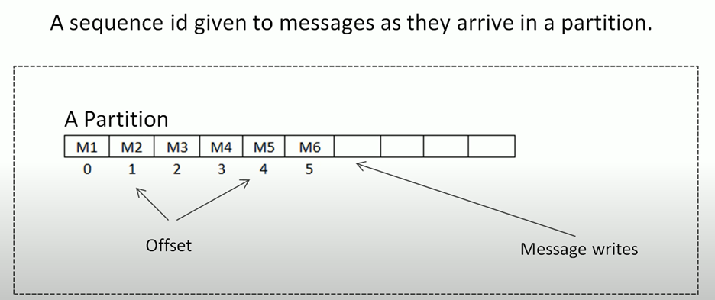

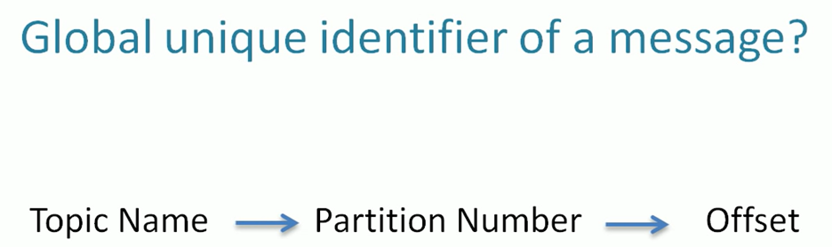

Need these three things to locate the message

Consumer Group :- A group of consumers acting as a single logical unit.

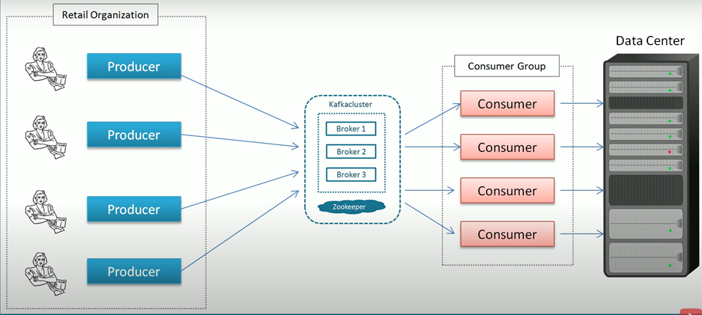

ZooKeeper is used in a**minor but crucial coordinating function** in newer versions of Kafka

Command for Start Zookeeper :

**.\bin\windows\zookeeper-server-start.bat .\config\zookeeper.properties**

Command for Start Kafka server :

**.\bin\windows\kafka-server-start.bat .\config\server.properties**

Command for Creating a Kafka Topic :-

**.\bin\windows\kafka-topics.bat --create --zookeeper localhost:2181 --replication-factor 1 --partition 1 --topic TestTopic**

kafka-topics --bootstrap-server localhost:9092

Note : Below command is working

**.\bin\windows\kafka-topics.bat --create --topic test-topic --bootstrap-server localhost:9092 --replication-factor 1 --partitions 4**

List All the kafka Topics use below command

**.\bin\windows\kafka-topics.bat --list --bootstrap-server localhost:9092**

kafka-topics --bootstrap-server localhost:9092 --list

Add Messages to our topics:-

Producer write messages

**.\bin\windows\kafka-console-producer.bat --broker-list localhost:9092 --topic test-topic**

Consumer Read Messages

**.\bin\windows\kafka-console-consumer.bat --bootstrap-server localhost:9092 --topic test-topic --from-beginning**

kafka-topics

kafka-topics --bootstrap-server localhost:9092 --list

kafka-topics --bootstrap-server localhost:9092 --topic first_topic --create

kafka-topics --bootstrap-server localhost:9092 --topic second_topic --create --partitions 3

kafka-topics --bootstrap-server localhost:9092 --topic third_topic --create --partitions 3 --replication-factor 2

# Create a topic (working)

kafka-topics --bootstrap-server localhost:9092 --topic third_topic --create --partitions 3 --replication-factor 1

# List topics

kafka-topics --bootstrap-server localhost:9092 --list

# Describe a topic

kafka-topics --bootstrap-server localhost:9092 --topic first_topic --describe

# Delete a topic

kafka-topics --bootstrap-server localhost:9092 --topic first_topic --delete

# (only works if delete.topic.enable=true)